# **NO SQL Customer Database**

### **Question (week-09)**

1. Create a collection by name Customers with the following attributes.Cust_id, Acc_Bal, Acc_Type
2. Insert at least 5 values into the table
3. Write a query to display those records whose total account balance is greater than 1200 of account type ‘Z’ for each customer_id.
4. Determine Minimum and Maximum account balance for each customer_id.
5. Export the created collection into local file system
6. Drop the table
7. Import a given csv dataset from the local file system into mongodb collection.

### **Create Table:**

db.**createCollection**("Customer");



# **Inserting values into the table.**

db.Customer.insertMany([{custid: 1, acc_bal:10000, acc_type:"Saving"},

{custid: 1, acc_bal:20000, acc_type: "Checking"},

{custid: 3,acc_bal:50000, acc_type: "Checking"},

{custid: 4, acc_bal:10000,acc_type: "Saving"},

{custid: 5, acc_bal:2000, acc_type: "Checking"}]);

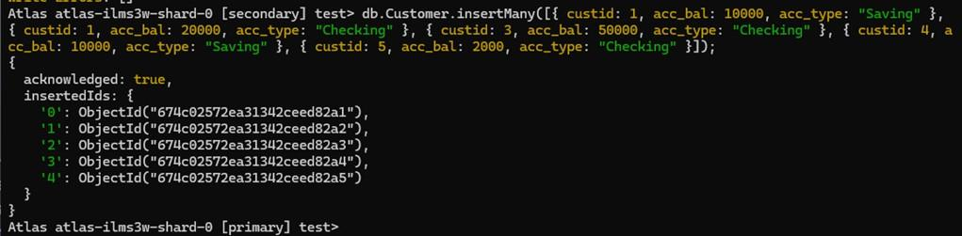

## **Queries**

Finding all checking accounts with balance greater than 12000 db.Customer.find({acc_bal: {$gt: 12000}, acc_type:"Checking"});

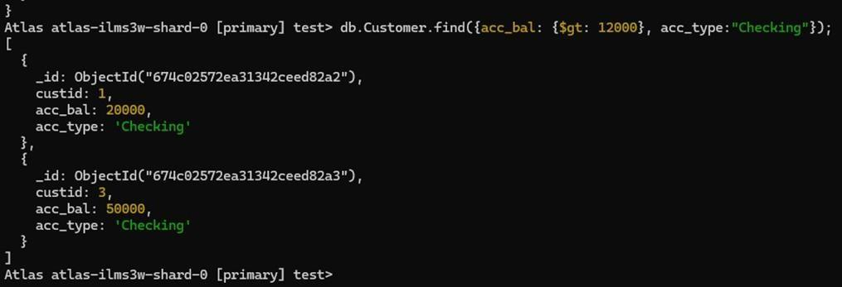

#### **Finding the maximum and minimum balance of each customer**

db.Customer.aggregate([{$group:{_id:"$custid", **minBal**:{$min:"$acc_bal"}, **maxBal**:{$max:"$acc_bal"}}}]);

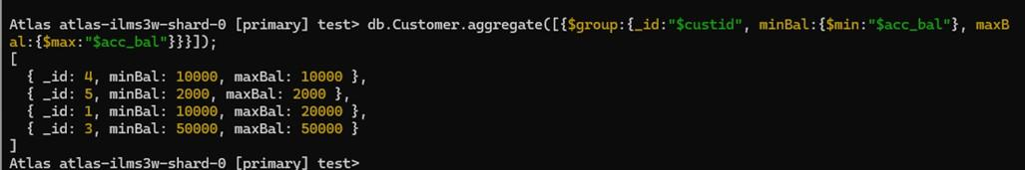

#### **Dropping collection “Customer”**

db.Customer.drop();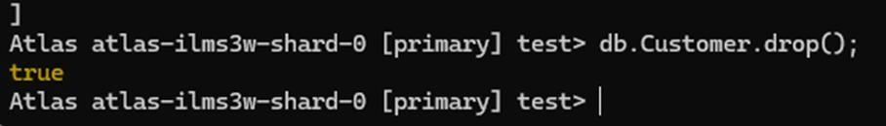

#### **Exporting the collection to a json file**

mongodb+srv://architavcs23:<db_password>@cluster0.memuu.mongodb.net/-- collection=Customer-- out C:\Users\vijay\Documents\test.Customer.json

#### **Exporting from a json file to the collection**

mongodb+srv://architavcs23:<db_password>@cluster0.memuu.mongodb.net/-- collection=Customer-- out C:\Users\vijay\Documents\test.Customer.json

db.Customer.find();